Brain Tumors
Brain tumors are abnormal growths of cells within the brain or central nervous system. They may be primary (originating in the brain) or metastatic (spread from other organs), and can be benign or malignant.

Types
- Glioblastoma
- Astrocytoma
- Meningioma
- Oligodendroglioma
- Ependymoma
- Medulloblastoma
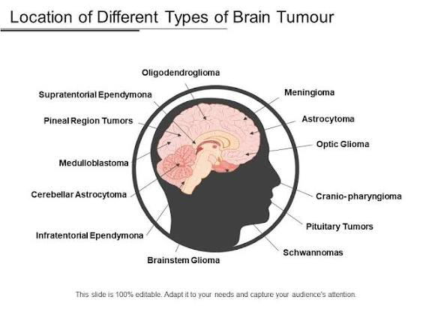

Brain Regions
Depends on tumor location:
- Frontal lobe
- Temporal lobe
- Parietal lobe
- Occipital lobe
- Cerebellum
- Brainstem
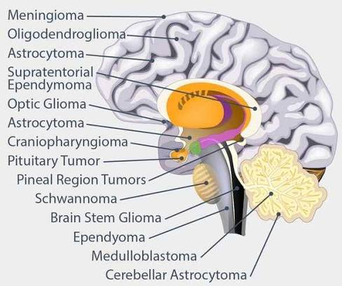

Pathophysiology
- DNA mutations
- Uncontrolled cell proliferation
- Angiogenesis
- Tumor invasion
- Increased intracranial pressure
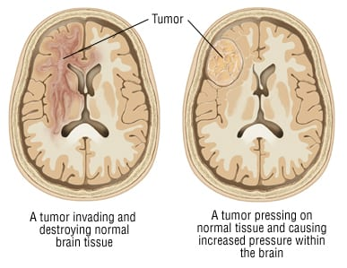

Genetics
- IDH1
- TP53
- EGFR
- ATRX
- MGMT

Symptoms
- Headache
- Seizures
- Weakness
- Vision changes
- Memory problems
- Personality changes

Diagnosis
- MRI
- CT
- Biopsy
- Histopathology
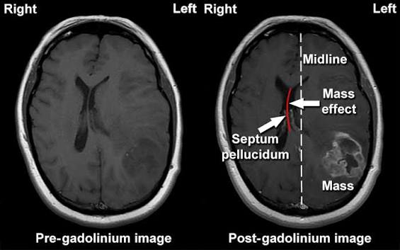

Treatment
- Surgery
- Radiation
- Chemotherapy
- Targeted therapy
- Immunotherapy

